# Financial Reporting

## Reading 21: Financial Statement Analysis: An Introduction

At the end of the income statement, the minority interest profit is subtracted.

**Basic EPS** – Uses weighted average number of common shares calculated by the total number of shares (not only the newly issued but the total) * period covered. Splits are treated as if they happened at the beginning of the period.

**Diluted EPS**- Same but considers that shares can be claimed due to conversions(conversions is assumed to happen at the beginning (or when issued)). The if-converted method is used for convertible preferred stock and dividends.

For stock option and warrants, the treasury stock method is used where all the instruments are converted and the proceeds from the conversion are used to repurchase stocks. So, the denominator addition will be calculated as (shares from exercise – repurchase) * proportion of the year where the instruments were outstanding.

|  |  |  |
| --- | --- | --- |
|  | Effect on numerator | Effect on denominator |
| Options | None | + shares issued   * shares retired |
| Convertible bonds | + after-tax interest avoided | + shares issued |
| Convertible preferred shares | + dividend claim avoided | + shares issued |

Paid-in-capital = Contributed capital. Additional paid-in-capital = premium paid over par value.

FFSS:

* Balance sheet -> resources that the company controls, obligations and owner up to a date.
* Income statement -> Performance on a period.
* OCI -> Items that affect equity that are not in the IS.
* Statement of changes in equity -> Changes in every balance of the items of equity.
* Cash flow statement -> sources and uses of cash. Direct and indirect method.

**Management discussion and analysis MD&A**:

1. Nature of business
2. Management’s objectives and strategies
3. Significant resources, risks and relationships
4. Results of operation
5. Critical performance measurements.

**Auditor’s report**:

* Parts: Intro, scope and opinion.
* Opinions: Unqualified, qualified, adverse, disclaimer of opinion.

## Reading 22: Financial reporting mechanics

Double-entry accounting = “a todo cargo corresponde un abono”

**Accruals**:

* Unearned (deferred) revenue - > Liability. Anticipo de clientes
* Unbilled (accrued) revenue -> Asset. No se ha facturado.
* Prepaid expense -> Asset.
* Accrued expenses -> liability. Porque no se ha reconocido pero ya se incurri[on..

Deferred: no ha pasado por el income statement, no se ha prestado el servicio

Accrued: ya se prest[o el servicio pero no se ha pagado o no se ha recibido el pago.

Flow of information in an accounting system:

1. Journal entries and adjusting entries.
2. General ledger and T-accounts. Here transactions are simply classified by account.
3. Trial balance and adjusted trial balance.
4. FFSS.

Trade receivables = accounts receivables.

Cash equivalents maturity < 90 days.

## Reading 23: Financial reporting standards

**International Accounting Standards Board (IASB)** installed The Conceptual Framework which includes:

* Rule-based standards: comprehensive and complex, specific guidance.
* Principles-based standards: more general, requires judgement.

Standard-Setting Bodies -> are private and self-regulated like the IASB or the **Financial Accounting Standards Board (FASB**).

Regulatory Authorities -> SEC.

IASB is in charge of the IFRS and has two entities:

* IFRS interpretations committee (review issues).
* IFRS advisory council (people affected by IFRS).

FASB is in charge of the US GAAP and its entities are:

* The Financial Accounting Foundation (manages the FSB).
* Advisory council.

Desirable attributes of accounting standards boards:

* Clear functions of the members.
* High professional, ethical and confidentiality standards.
* Adequate authority, resources and competences.
* Clear and consistent processes.
* Clear objectives.
* Independent.

**International Organization of Securities Commissions**: group of different governmental entities (90% of world’s financial markets).

**SEC** -> Securities Act of 93, Securities Exchange Act of 34, Sarbanes-Oxley Act of 2002, Dodd-Frank.

SEC Filings:

* Securities Offerings Registration Statement.
* Forms 10-k, 20-F and 40-F (the annual report filing).
* Form DEF-14A (proxy statement).
* Forms 10-Q and 6-K (quarterly reports, unaudited.).
* Form 8-K and 6-K (announces).
* Form 144 (sale of restrictive securities).
* Form 3, 4 and 5: required when someone owns more than 10%. 3 = Intial state, 4 = changes and 5 = annual report.
* 11-K (report employ stock purchase, savigns…).

**IFRS FRAMEWORK**

Objective: provide information for decision making in terms of financial position, performance and cash flows.

Qualitative characteristics (the first two are the fundamental):

* + Relevance (materiality).
  + Faithful representation (complete, neutral and free of error).
  + Comparability (with the past).

Features

* + Verifiability (qualified users agree that it is presented faithfully).
  + Timelines.
  + Understandability.
  + Consistency.
  + No offsetting.

Underlying assumptions:

* + Accrual accounting.
  + Going concern.

Measurement of elements:

* + Historical cost.
  + Amortized cost.
  + Current cost (entry price, replacement cost) (Amount of cash to buy the same asset. For liabilities is the undiscounted amount of cash needed to settle the obligation today). This method considers all the costs incurred in replacing the asset.
  + Realizable (settlement) value (exit price) (cash received for selling or disposing the asset). For liabilities, the undiscounted cash needed to settle the debt in the normal course of business). (no me queda muy claro la diferencia con el anterior en los liabilities).
  + Present value of expected CF.
  + Fair value: amount at which assets could be exchanged or liabilities settled in a transaction. Is the market value

Notes to the FFSS:

* + Disclosure of accounting policies.
  + Sources of estimation uncertainty.
  + Other disclosures.

## Reading 24: Understanding income statements

Grouping by nature -> for example, groups by depreciations.

Grouping by function -> fro example, groups by COGS.

Multi-step format -> includes subtotals.

Single-step format -> does not include subtotals.

Income -> main activities.

Gains -> secondary activities.

**Revenue recognition** -> when its earned, when risk and reward of ownership is transferred (policies must be disclosed).

**Special cases**:

For **long-term contracts** (if loss is expected, it should be reported):

* + - Percentage-of-completion: based on the estimate of completion or based on the expenditure incurred.

*When this is not reliable, the methods used are in the IFRS vs US GAAP table.

For **installment sales**:

*Check the IFRS vs US GAAP table.

For **barter (non-monetary exchanges)**:

*Check the IFRS vs US GAAP table.

**Gross vs Net reporting**:

*Check the IFRS vs US GAAP table.

**Expense recognition ->** are recognized when they are consumed.

* Matching principle: expenses associated with revenues are recognized in the same period.
* Period costs: do not match the revenue and are reflected when the expenditure is made.
* Inventory costing method.

Doubtful accounts represent are matched with an expense as the direct write-off method is not accepted (where the loss is only recognized when the costumer defaults in its payment).

Warranties expenses must also be estimated.

**Depreciation methods:**

* Straight-line.
* Diminishing balance (accelerated): allocates more depreciation to the early years. It is calculated by multiplying the depreciation rate under straight line method by a factor (if it is 200%, it is known as double declining balance depreciation). When it reaches to the period of the residual value, simply the difference between the balance and the residual value is recognized as the expense.

Assets with indefinite life are not depreciated nor amortized.

Discontinued operation -> disposal of a set of operations, should not be considered.

Unusual or infrequent items -> have an unlikely reoccurrence and must be presented separately.

Extraordinary items -> not used anymore.

Simple capital structure -> no instruments than can be potentially converted to common stock (complex capital structure).

**Comprehensive income:** includes NI and other revenue and expenses items:

1. Foreign currency translation adjustments when consolidating financial statements of foreign subsidiaries.
2. Unrealized gains or losses on derivatives accounted for as hedges (changes in fair value).
3. Unrealized holdings gains and losses on **available-for-sale** (not trade, **trading securities** will be reported in the income statement) securities.
4. Certain costs of a company’s defined benefit post-retirement plans that are not recognized in the current period.

## Reading 25: Understanding Balance Sheets

Own -> Asset

Owe -> Liability

Residual interest -> Equity

Current assets (or liabilities): realized (or settled) in cash after one operating cycle or one year if the operating cycle is less than a year.

Liquidity-based presentation -> usually used by banks.

**Current assets**

* Cash and cash equivalents: have a minimum interest rate risk due to its short maturity. It is measured at its amortized cost (historical – amort – impairment) or fair value.
* Marketable securities: investments in publicly traded securities.
* Trade receivables: measured at realizable value, only the products which are already sold.
* Inventories: Can be measured through standard cost or the retail method (sales are reduced by the gross margin).
* Other current assets:
  + Prepaid expenses.
  + Deferred tax assets.

**Current liabilities:**

* Trade payables.
* Notes payable: financial liabilities.
* Accrued expenses (non-paid recognized expenses).
* Deferred income (uncollected income).

**Non-current assets:**

* PP&E: the measurement methodology selected needs to be used to all the assets of the same class.
* Investment property: property not used for goosds production nor administrative purposes.
* Intangible assets: if it has a finite lifespan, it is amortized. For infinite lifespan, the assumption must be checked once a year. Impairment tests need to be done. Intangibles are recognized only if they have probable future benefits. Internally created intangibles are recognized as expenses.
* Accounting goodwill (different from economic goodwill, which is reflected in the market stock price). It must be tested for impairment annually.
* Financial assets: measured at fair value (for trading and available for sale assets. Changes are recognized as unrealized gains or losses in the IS or OCI and, when sold, the gain or loss (carrying amount – selling price) is recognized in the IS) or amortized cost (if cash flows happen on a certain date).

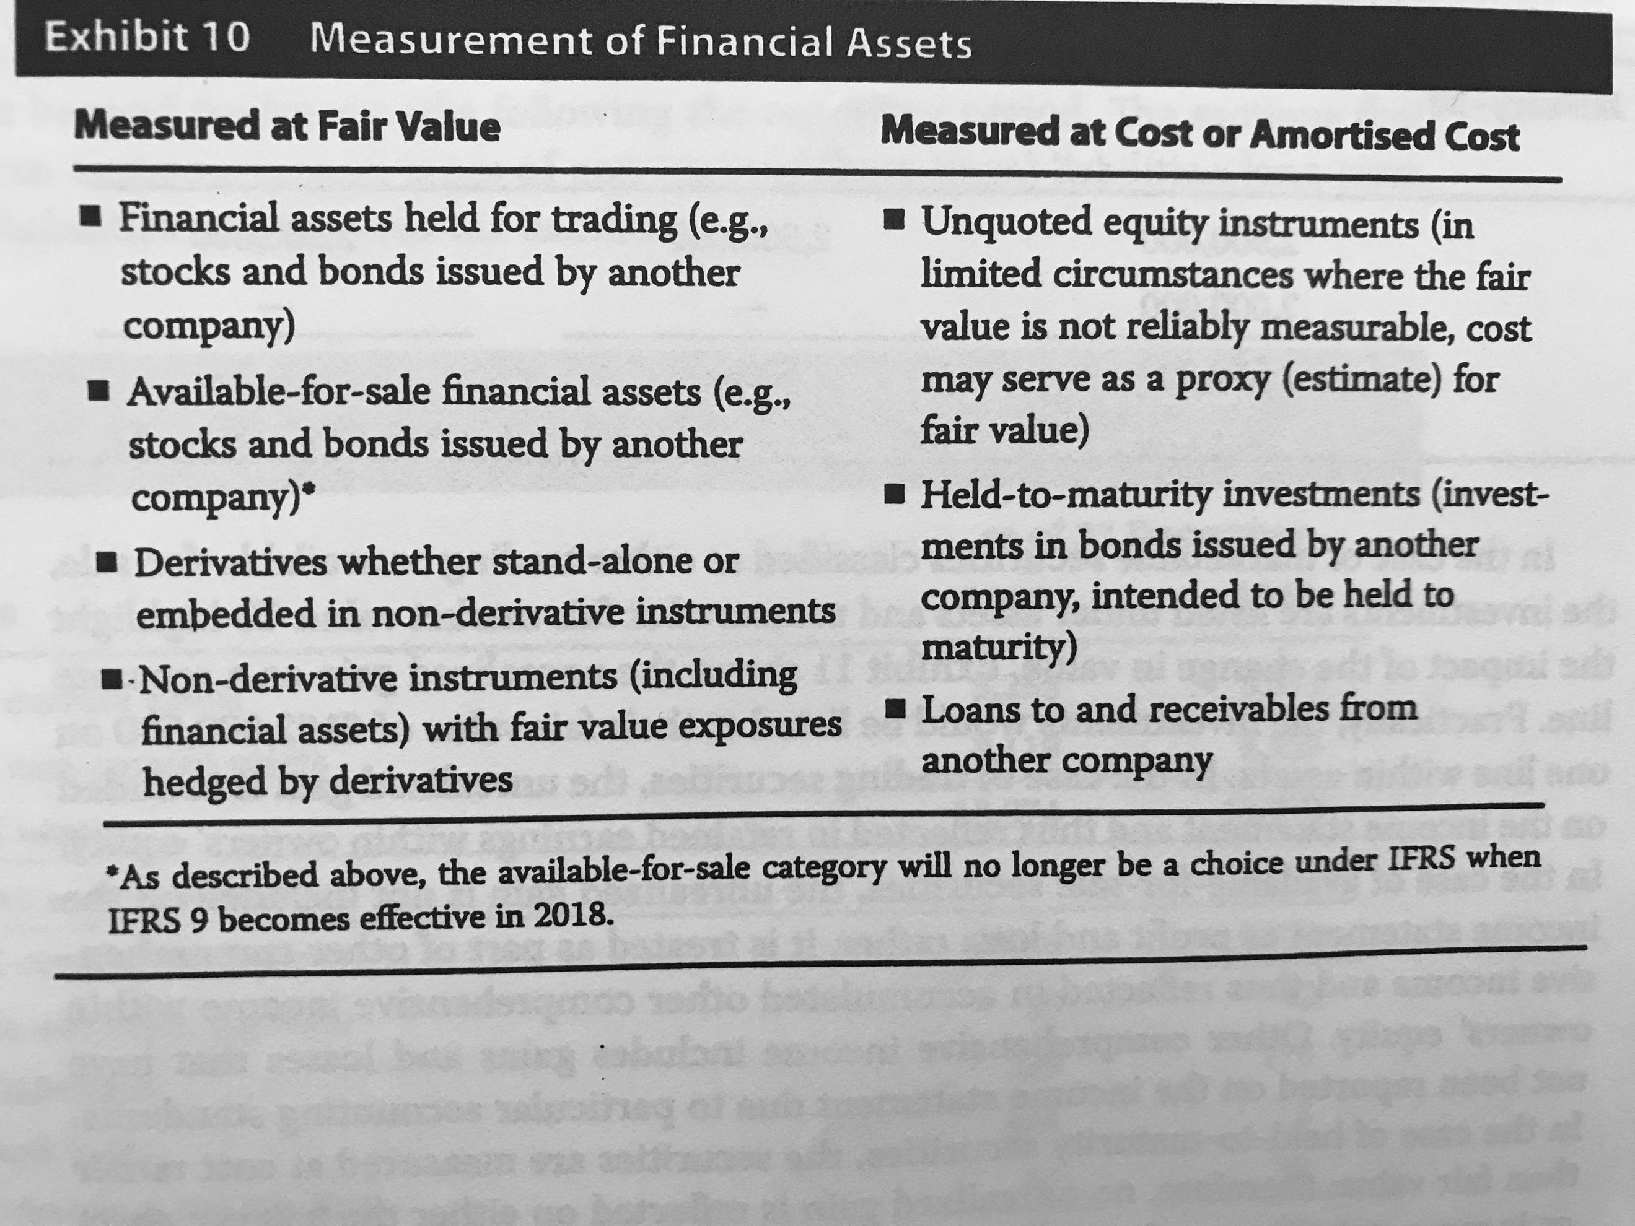

**Non-current liabilities:**

* Long term financial liabilities: reported at amortized cost, unless they are held for trading (measured with fair value).
* Deferred tax liabilities: due to difference between reported income and taxable income.

*Impairment: when the recoverable amount is less than the carrying amount.

*Goodwill and impairment losses should be excluded when making ratio and trend analysis.

**Equity**

* Capital contributed by owners.
* Preferred shares.
* Treasury shares: repurchased by the company and not yet cancelled (they have no voting nor dividends rights).
* Retained earnings.
* Accumulated OCI.
* Non-controlling interest.

**Statements of changes in equity:**

* Total comprehensive income.
* Reconciliation of every balance.

## Reading 26: Understanding cash flow statement

Accounts payable is an operating account.

**Direct method:**

**Operating activities:**

* Cash received from customers: Revenues can be adjusted by subtracting net change in receivables.
* Cash paid to suppliers: COGS + change in inv – change in AP.
* Cash paid for other operating expenses: add change in prepaid expenses – change of other accrued liabilities.
* Cash paid for interest: interest expense minus change of interest payable.
* Cash paid for income taxes: income tax plus net change in tax receivables – changes in tax payable.

*This adds up to the cash used, because a change in inventory should consume class, not generate.

**Investing activities**

**Financing activities:**

* Long term debt and common stock.
* Dividends.

**Indirect method:**

Adjustments to net income to reach CFO:

* Non-operating activities.
* Non-cash expenses.
* Changes in WC.

**From indirect to direct method:**

1. Disaggregate the net income into total revenue and total expenses.
2. Remove any non-operating and non-cash items.
3. Convert accrual amounts of revenues and expenses to cash flow amounts and receipts and payments by adjusting for changes in working capital accounts.

**Common-size ->** As a percentage of total revenues or total inflows or outflows (depending on the nature).

Ratios:

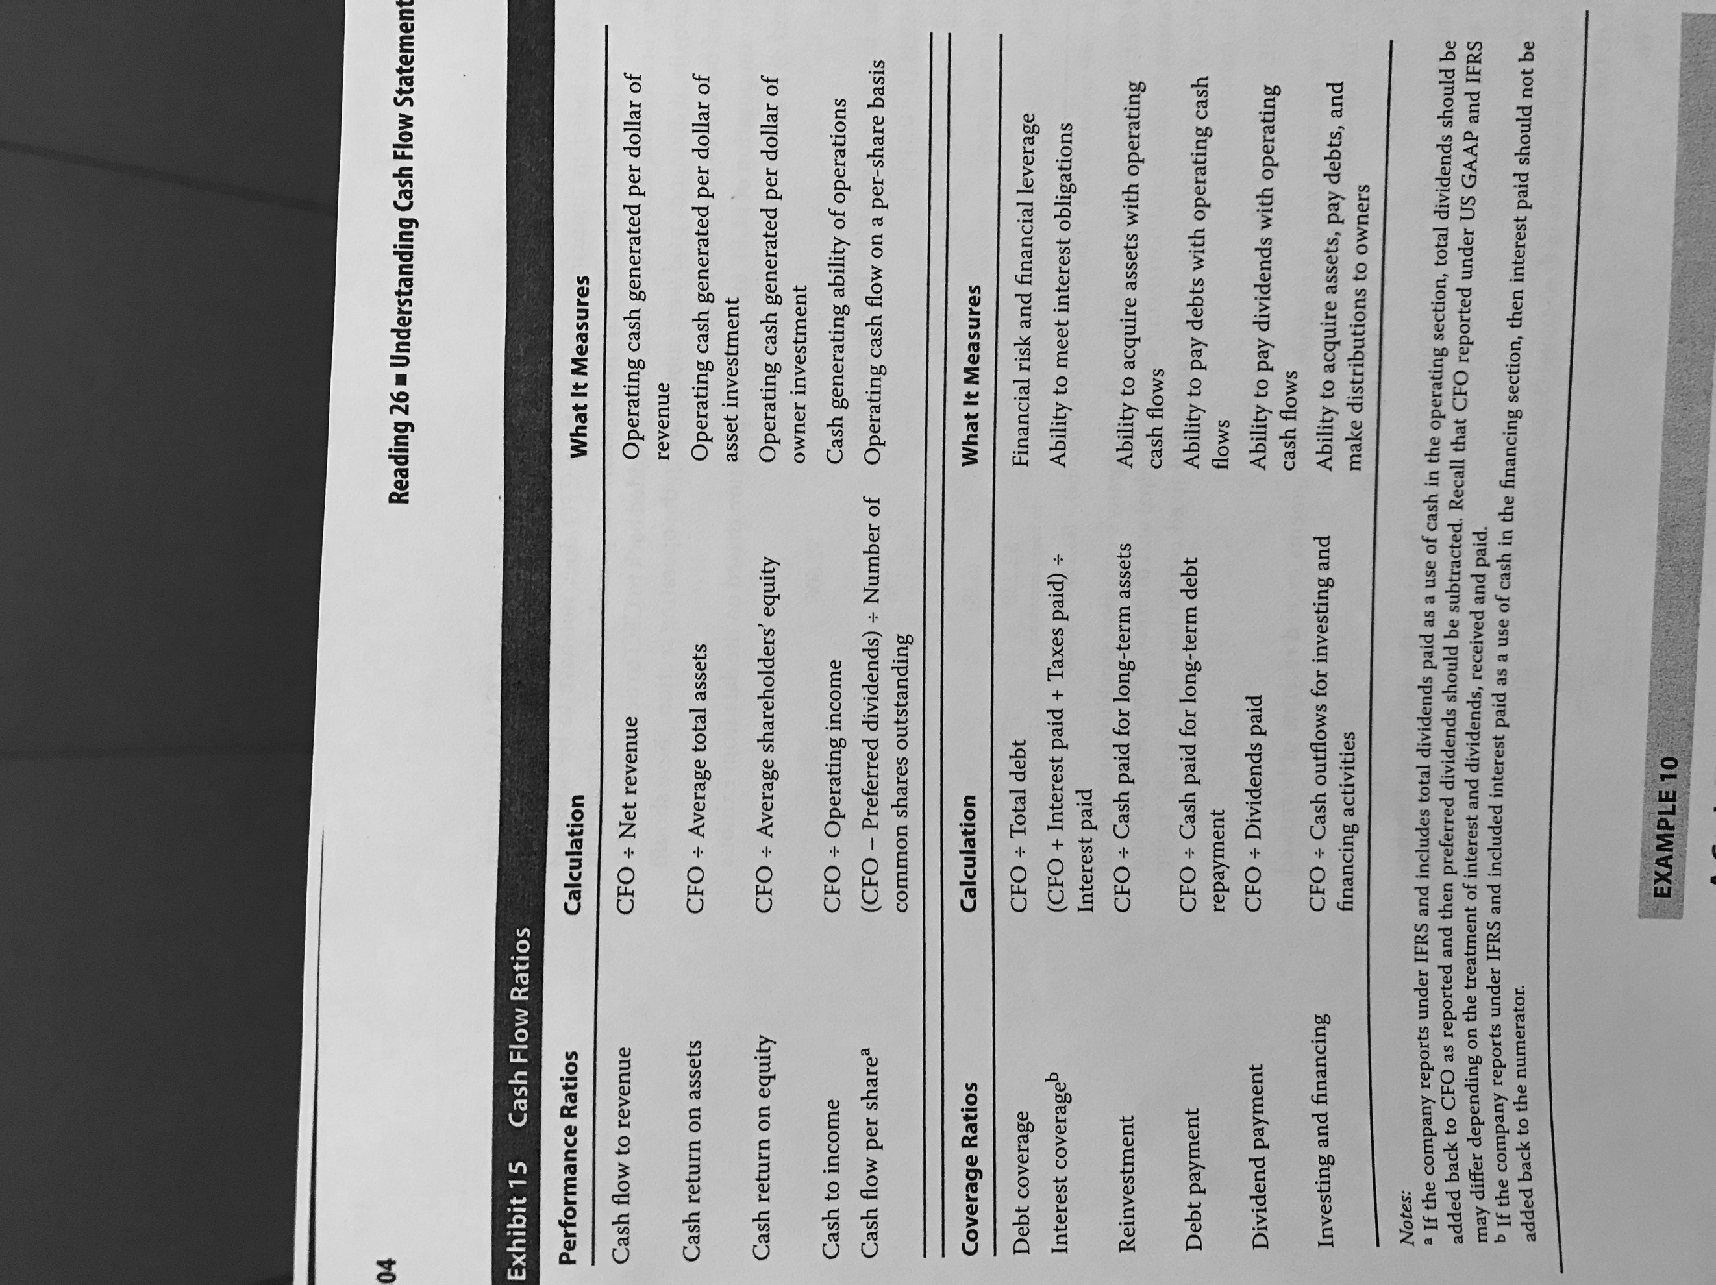

## Reading 27: Financial Analysis Techniques

Steps in performing analysis

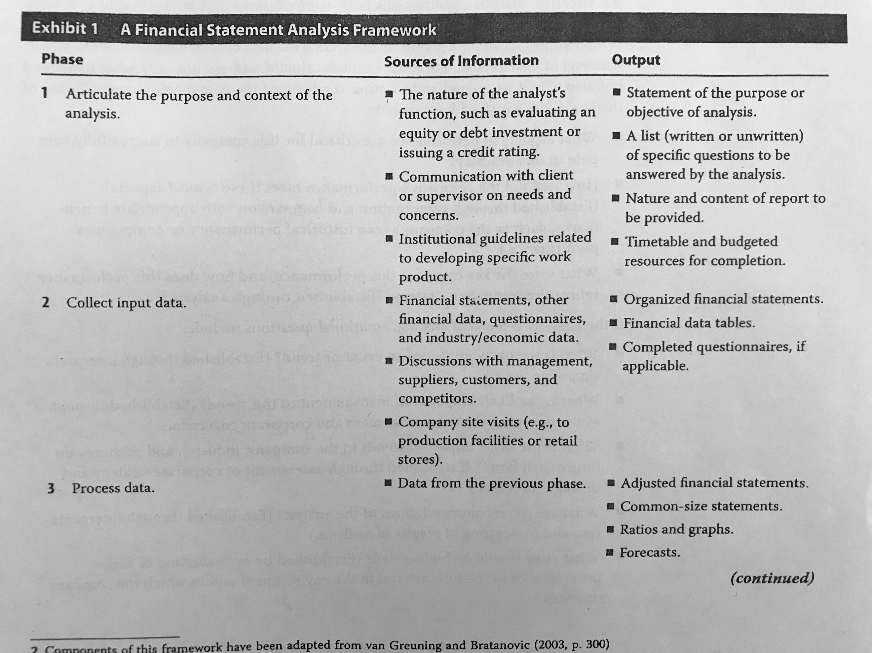

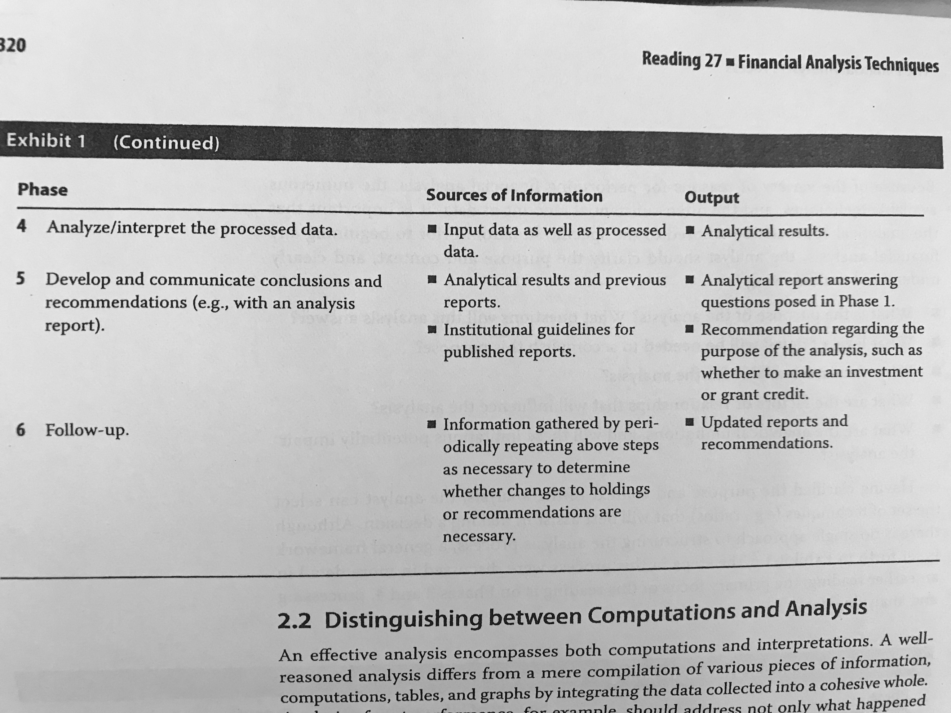

Report format:

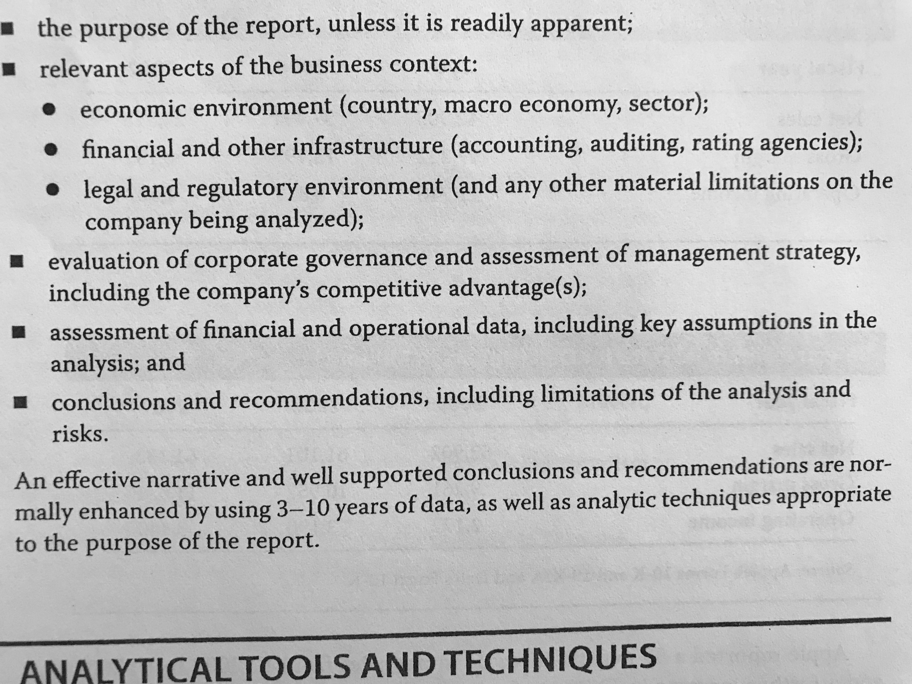

Common size can be vertical or horizontal (normal analysis).

For the common size of financial institutions IS, the base can be the total assets.

**Types of ratios:**

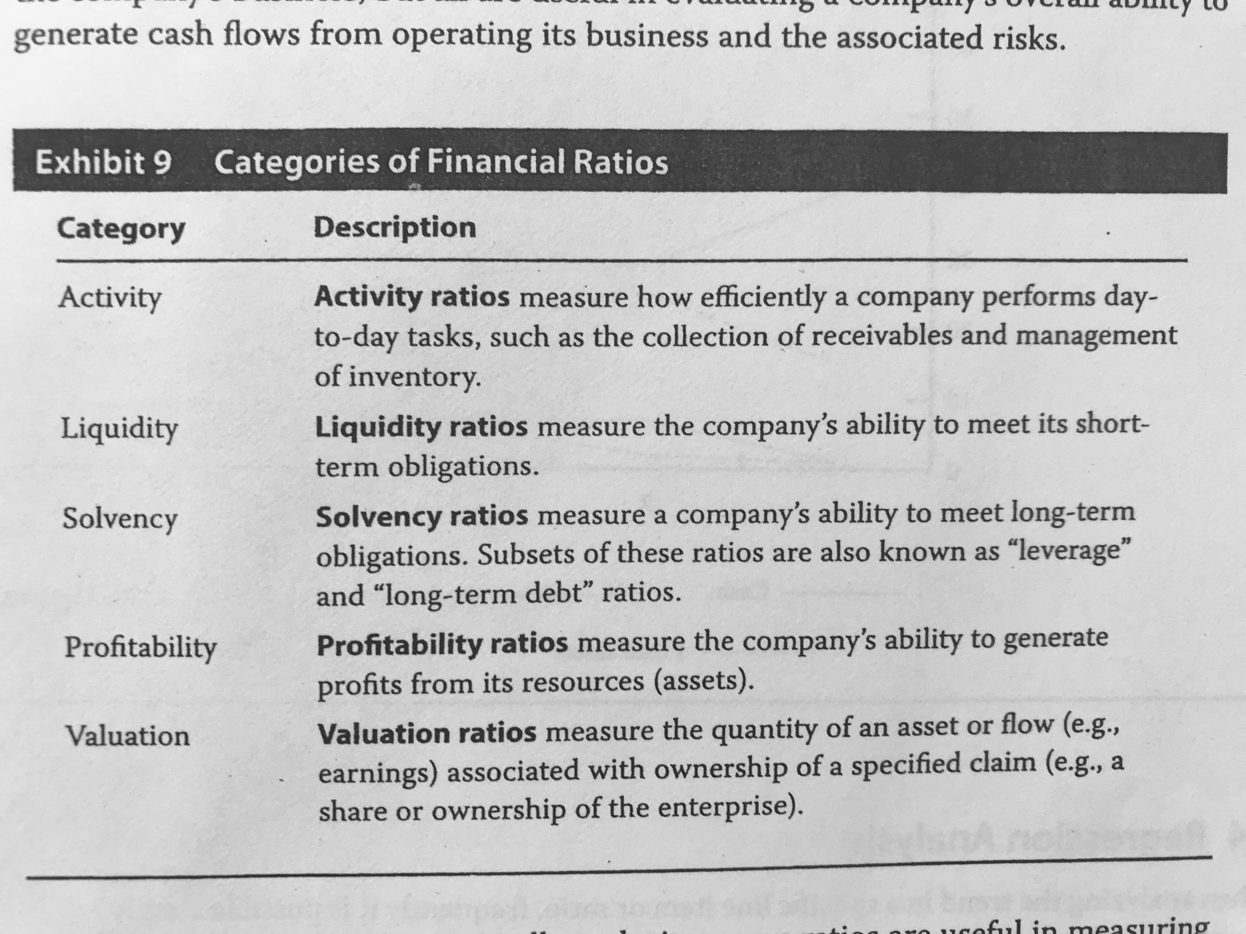

**Activity ratios:**

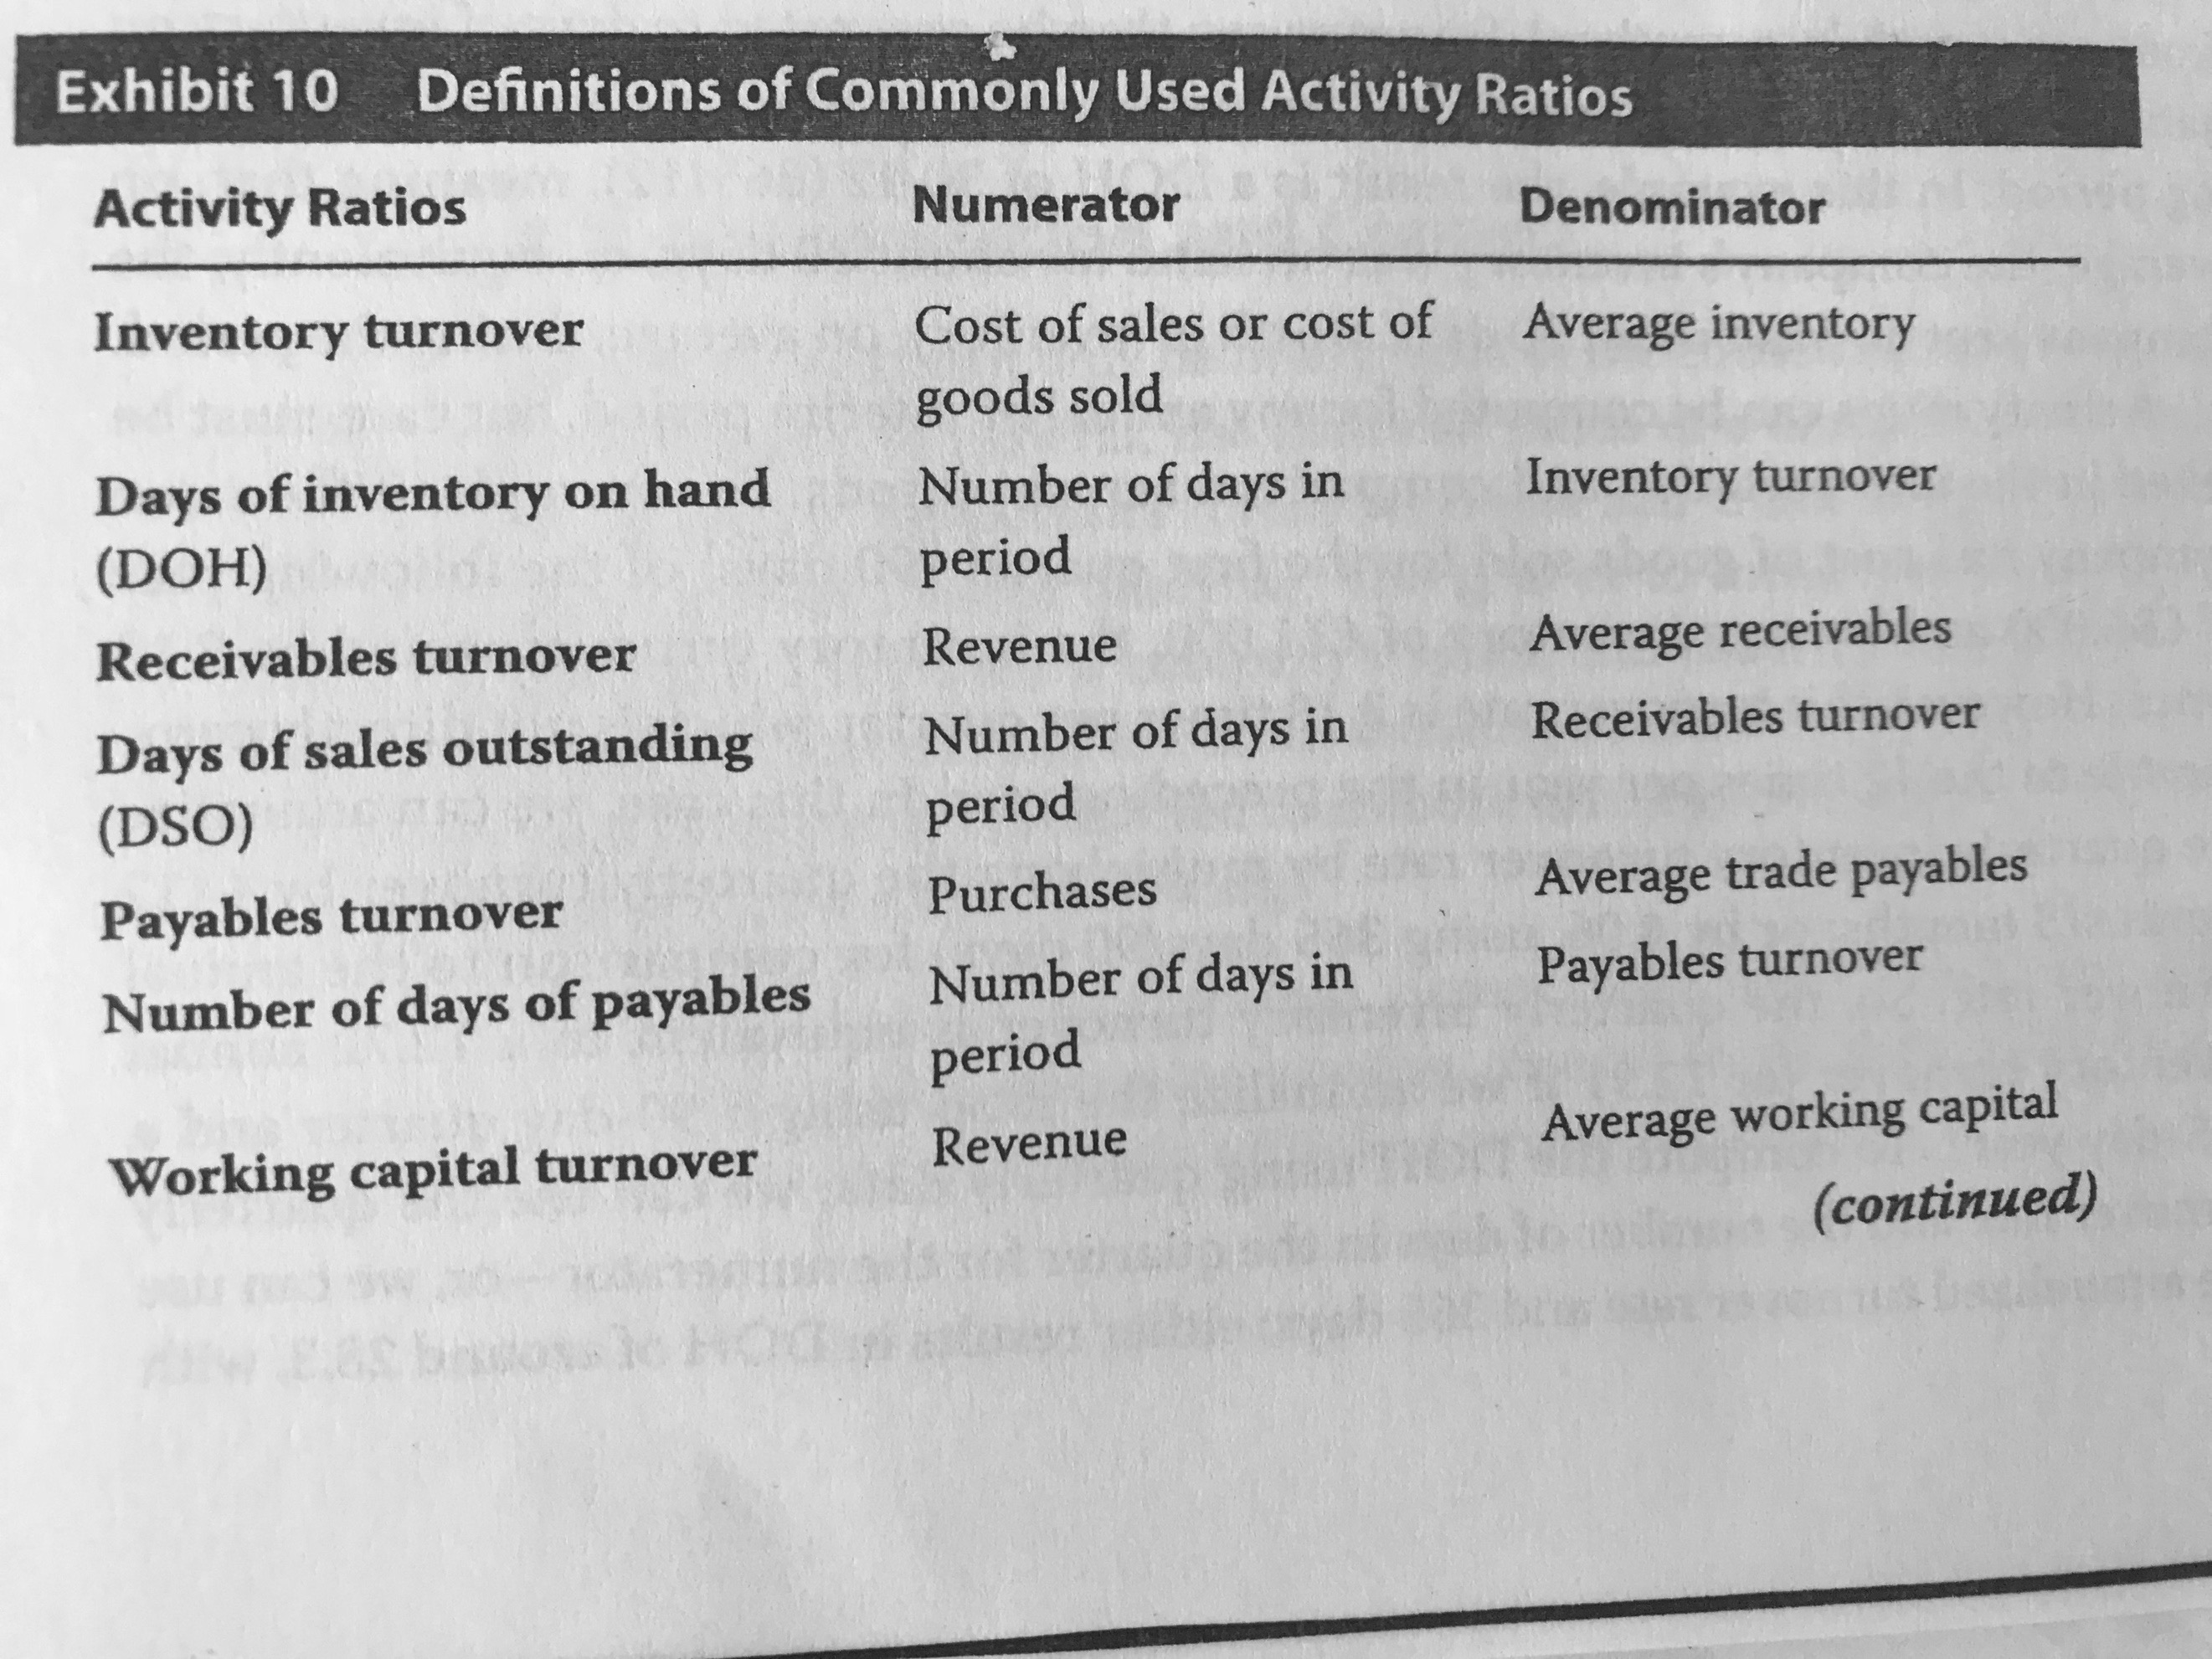

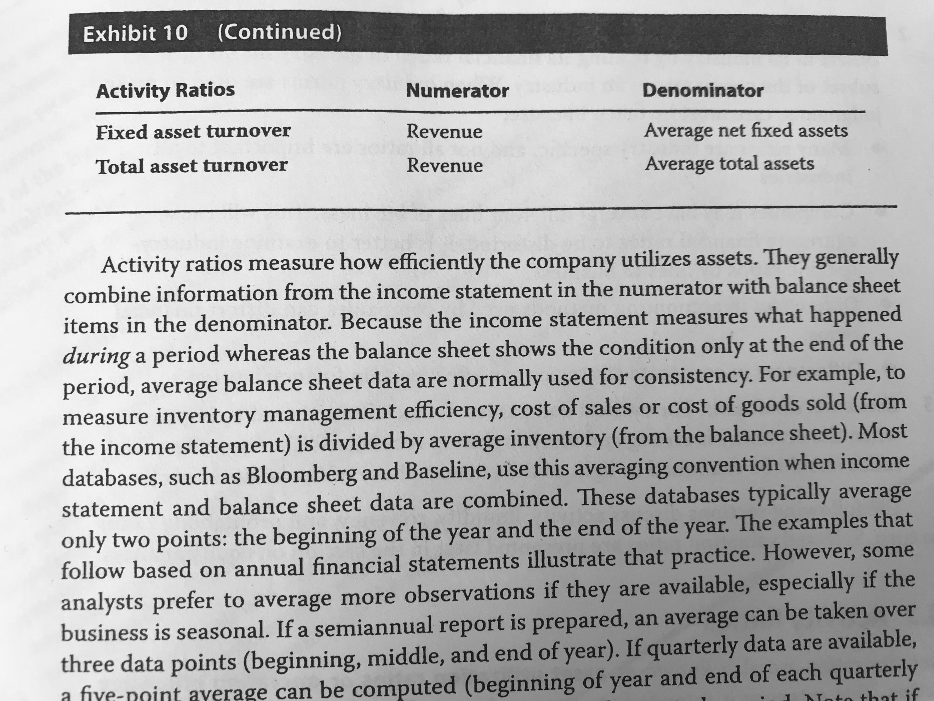

To determine the balance of operating accounts, I need to consider the days depending on the date to which the balance wants to be estimated in the future.

Interpretations:

* + ITO: a high ITO can mean that the company is being more efficient (if revenue is also growing) or that the quantity of inventory is too low.
  + RTO: a high RTO could mean that the company is more efficient collecting cash (if revenue is also growing) or that it has too tight credit policies.
  + PTO: a high RTO could mean that the company is not making good use of credit facilities, unless it is taking advantage from early payments. If liquidity is low and PTO is low, it could mean that it is not paying.
  + Working capital turnover.
  + Fixed assets turnover: this ratio is affected by depreciation and new acquisitions (which does not make immediate effects in efficiency).
  + Total asset turnover.

**Liquidity ratios:**

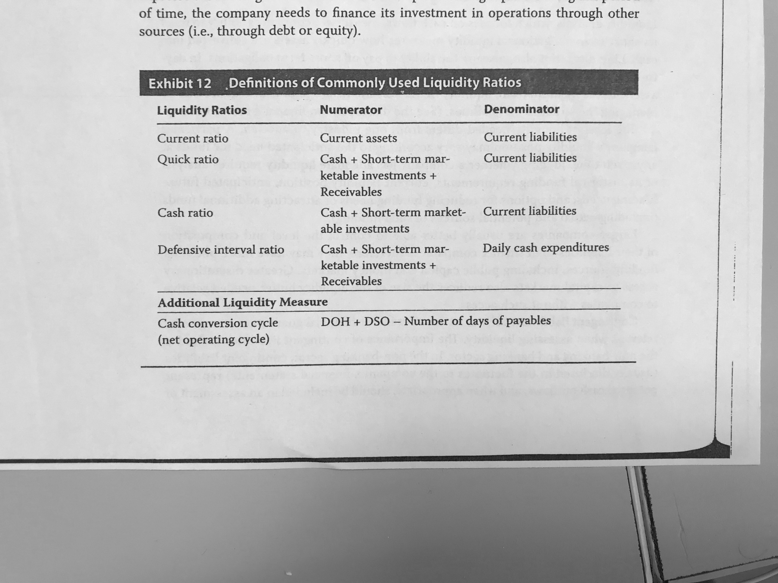

**Solvency rations:**

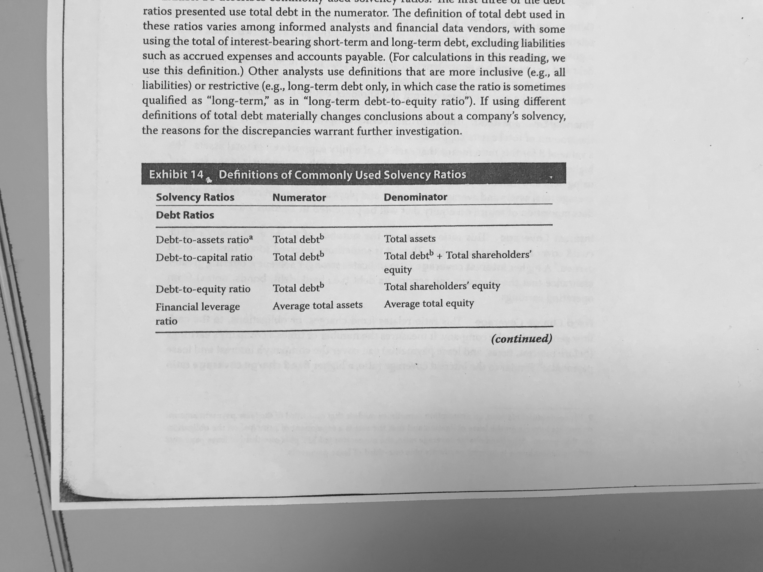

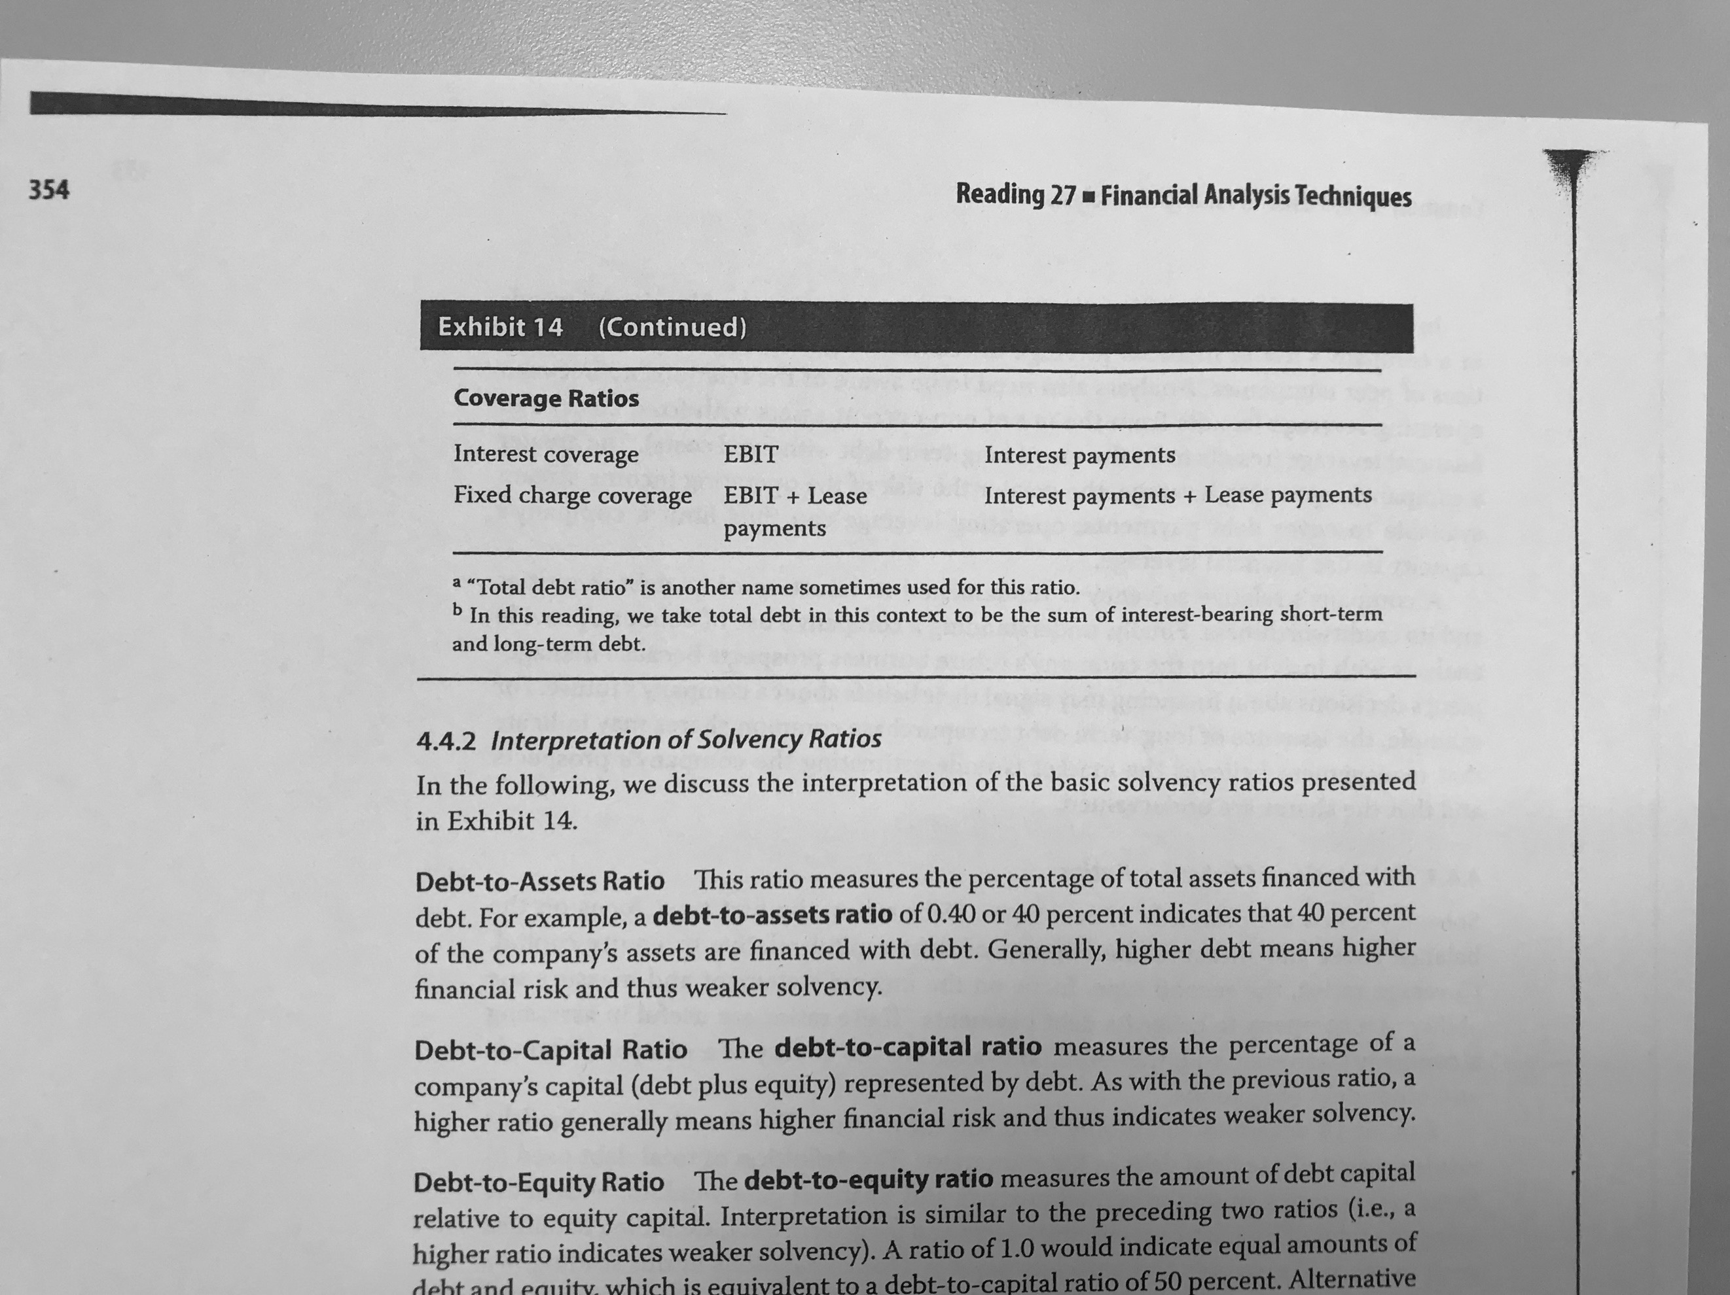

**Profitability ratios**

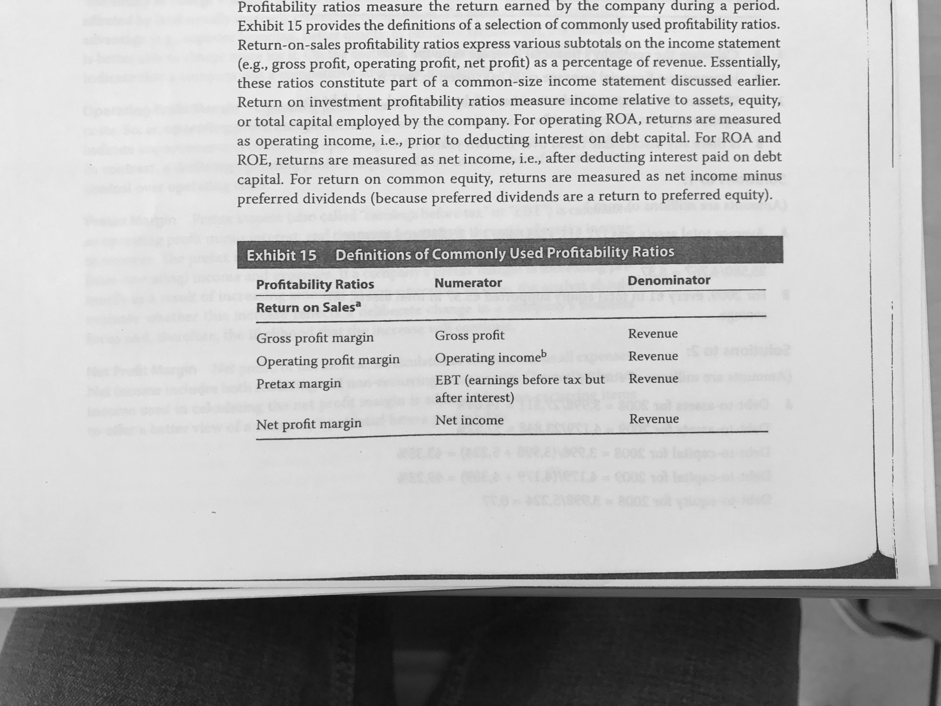

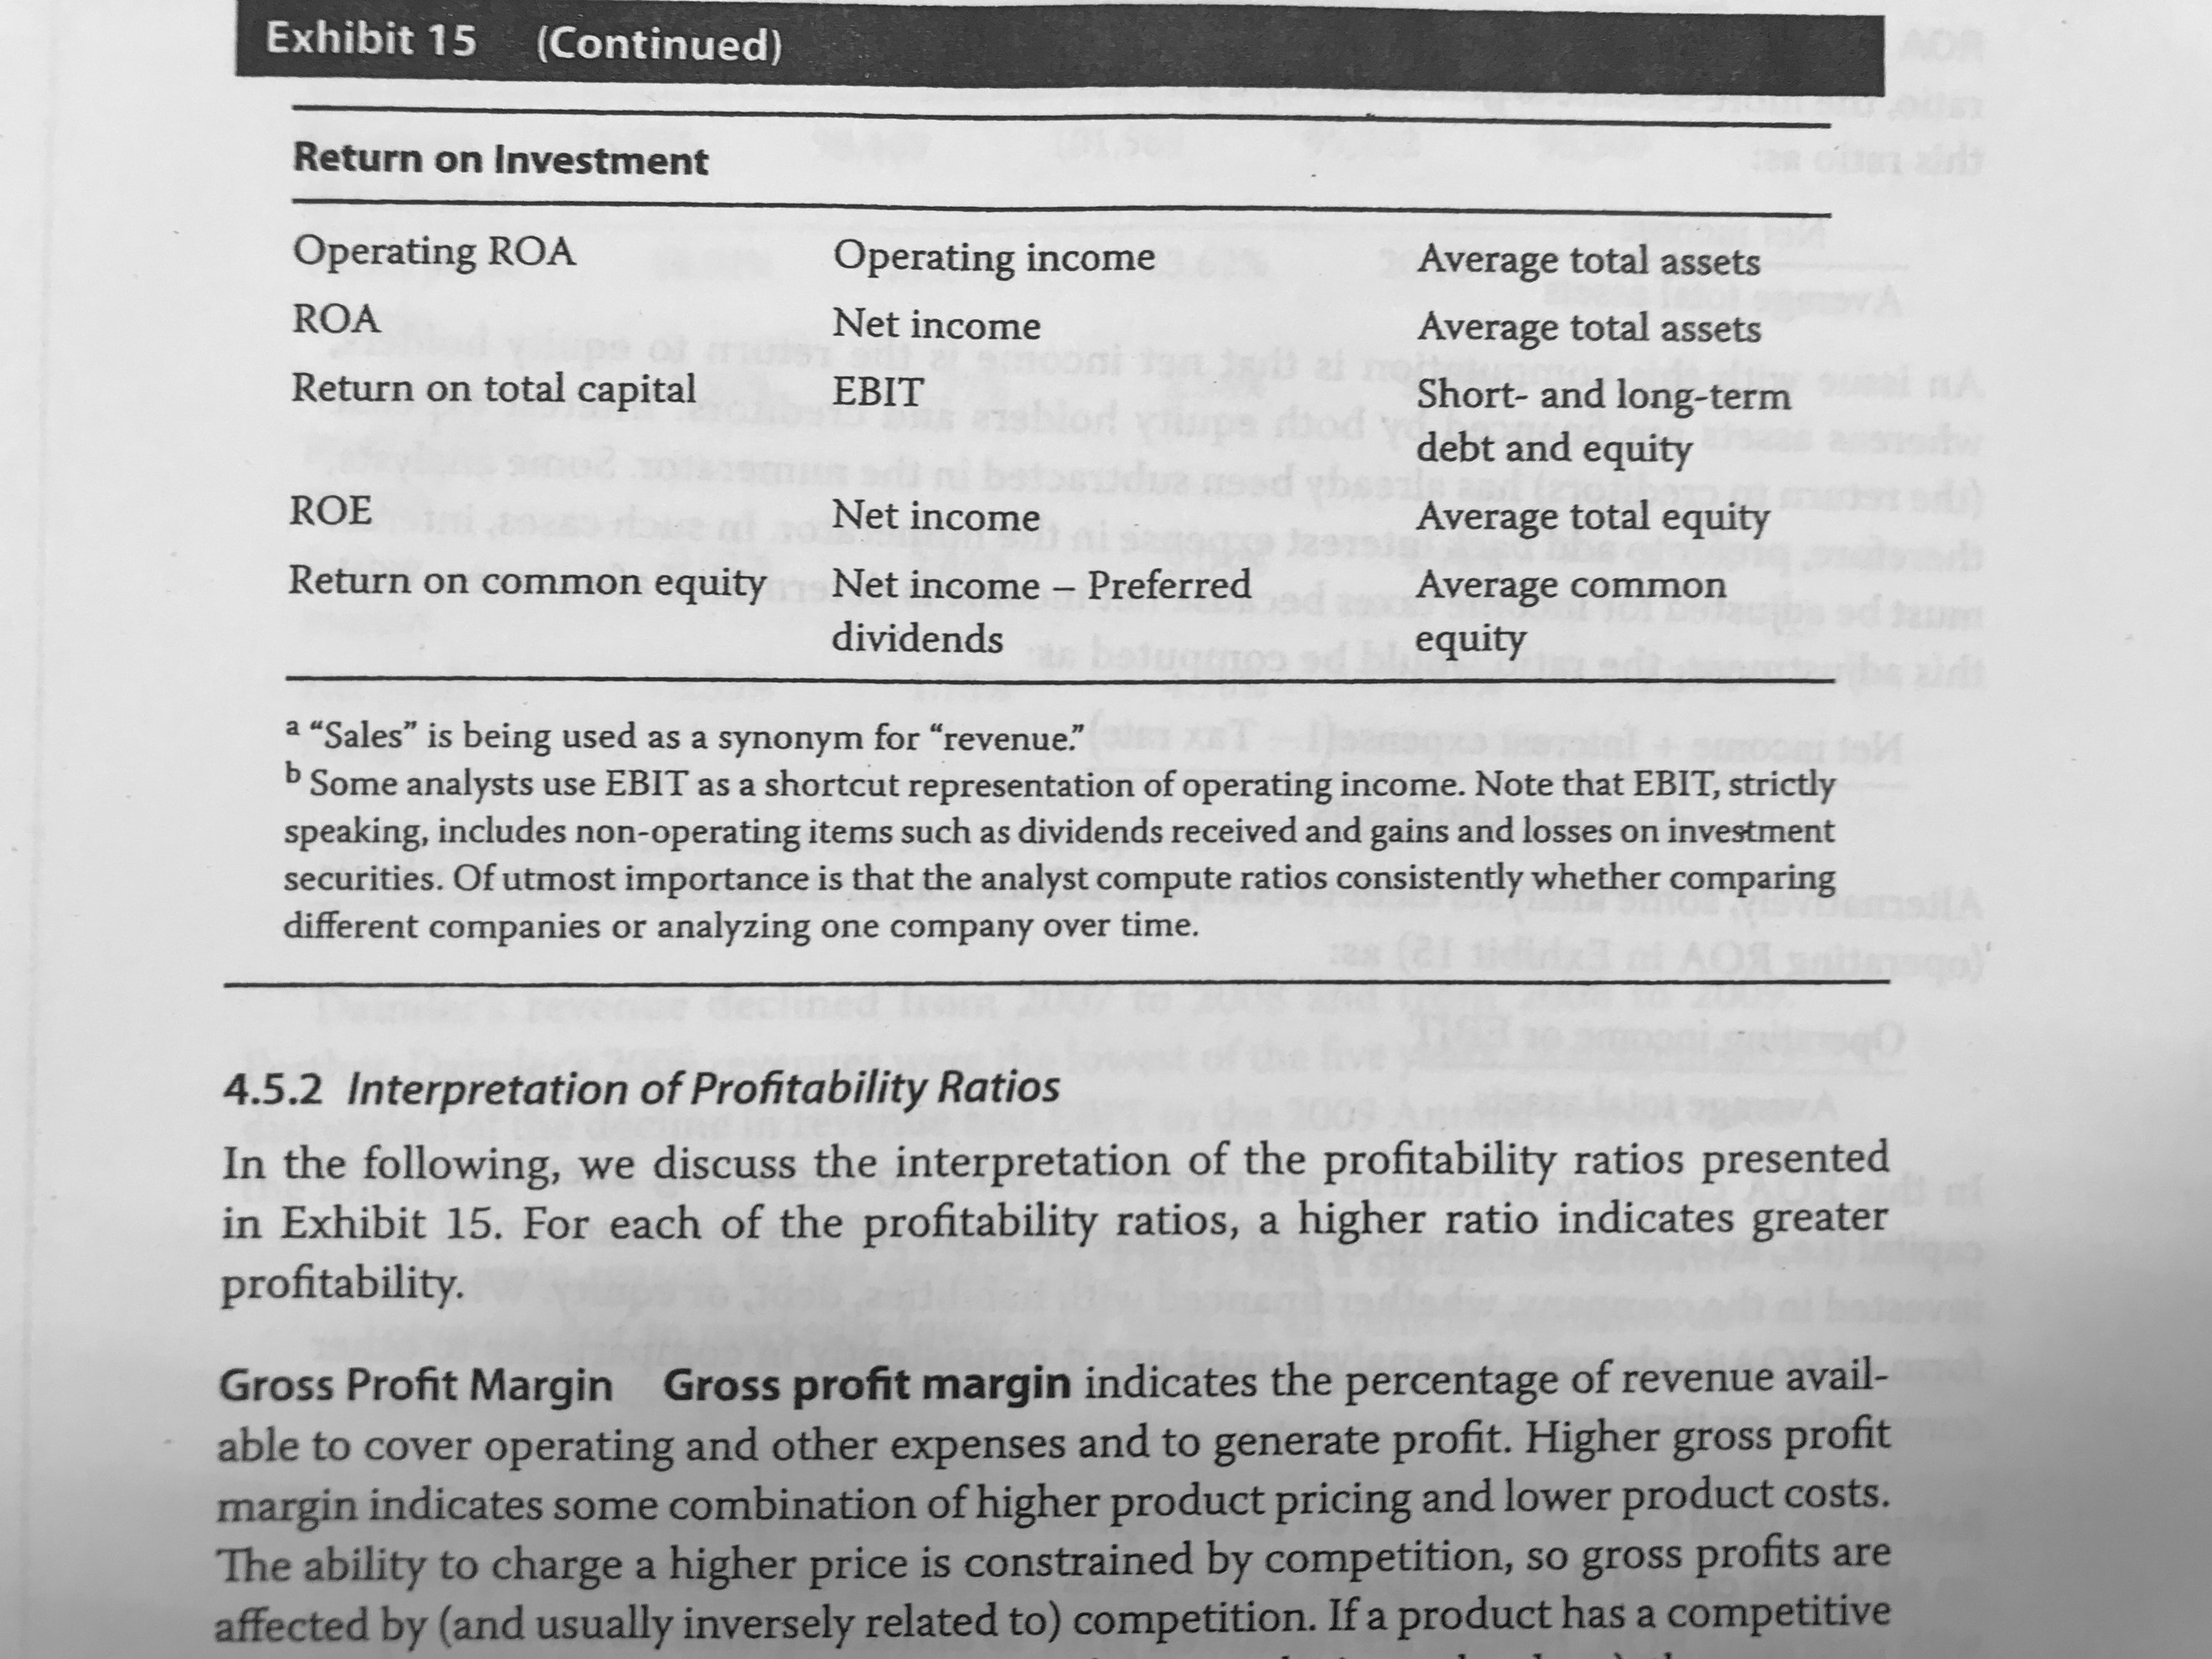

A high gross margin could be a signal of the existence of a competitive advantage.

**DuPont Analysis alternative**

$$ROE= \frac{Net income}{EBT}×\frac{EBT}{EBIT}×\frac{EBIT}{Revenue}×\frac{Revenue}{Avg. total assets}×\frac{Avg. total assets}{Avg. shareholder^{'}s equity}$$

**Valuation ratios:**

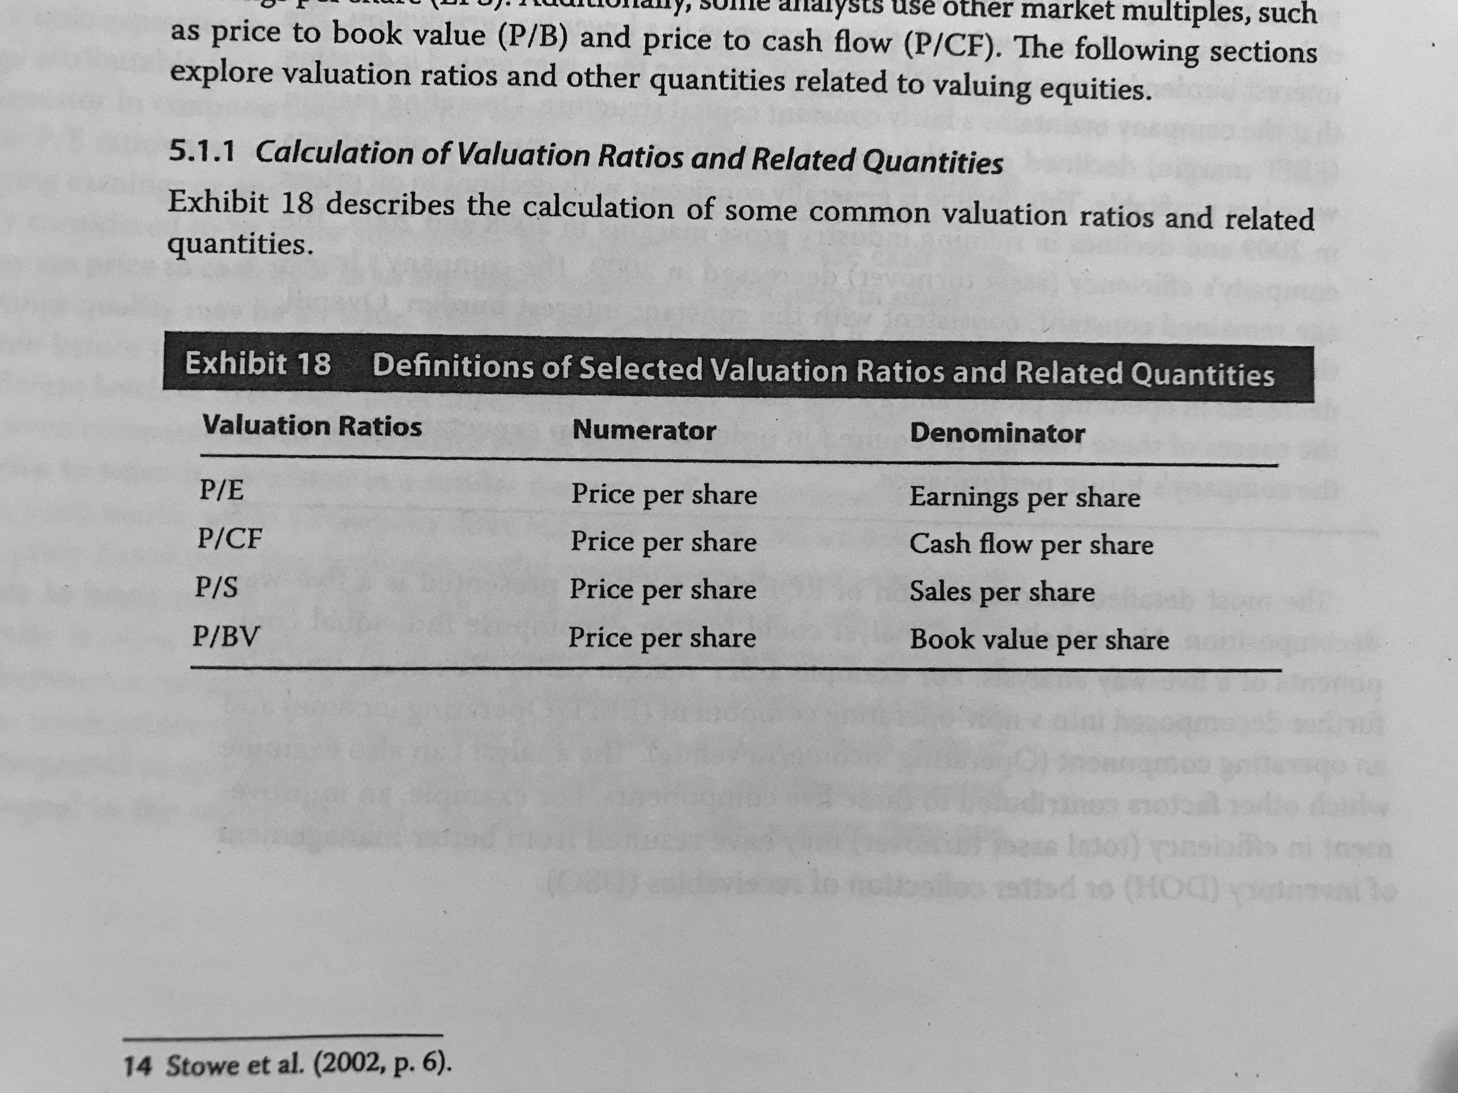

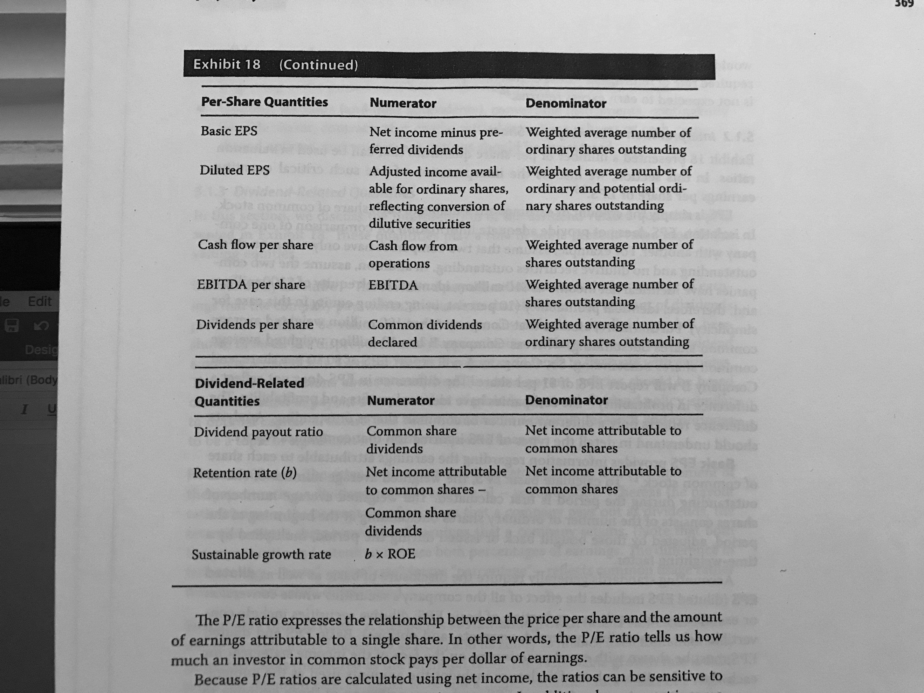

**Credit analysis uses these ratios:**

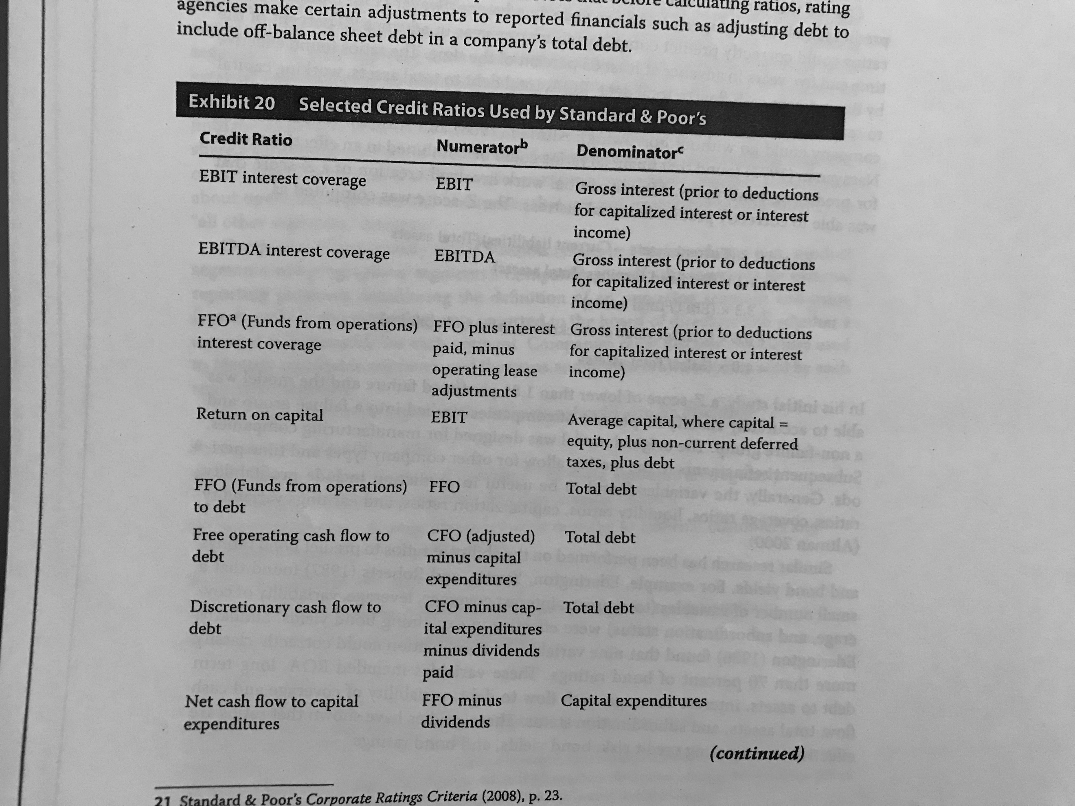

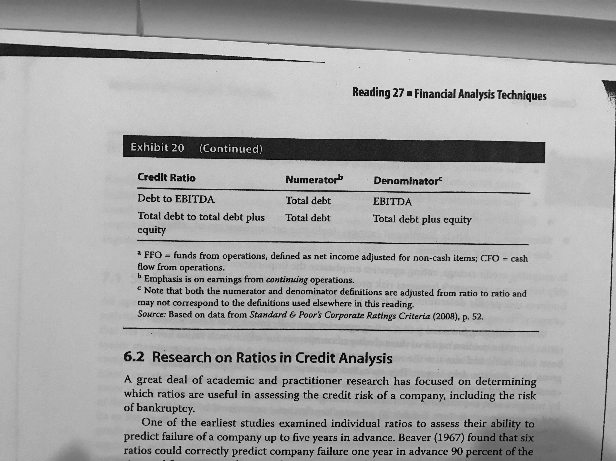

**Z-Altman ->** when it is < 1.81, predicts failure.

**Operating segment:** generates revenue and creates expense, results are reviewed by senior management and financial information is available.

If a segments has more than 10% of the revenue, assets or profit, specific information must be disclosed. At least 75% of the revenue combined must be disclosed, if not, the company needs to continue disclosing.

The rest go in an “all other segments” category.

*If a customer represents more than 10% of revenues, it should be disclosed.

## Reading 28: Inventories

Abnormal costs are not considered as part of the cost of inventory.

Production overhead costs = costos indirectos de fabricación.

**Valuation methods:**

* Specific indentification.
* FIFO.
* Weighted average cost.
* LIFO (must include a LIFO reserve = FIFO – LIFO. COGS can be adjusted from LIFO to FIFO by subtracting the increase in LIFO reserve during the period).

**Periodic inventory system** -> inventory and COGS are valued at the end of the period.

**Perpetual inventory system** -> COGS and inventory are continuously updated.

*LIFO and weighted average are affected when changing.

LIFO liquidation -> units sold > manufactured units. Might increase gross profit when prices are rising.

## Reading 29: Long-lived assets

PP&E: installation transactions are capitalized. Long projects that end with a fixed assets need to have all of its costs capitalized.

Intangible assets in different cases to a business combinations should be recorded at fair value.

Identifiable intangible assets must be:

1. Identifiable.
2. Under control of the company.
3. Expected to generate future economic benefits.
4. It is probable that the expected future economic benefits will flow to the company.
5. The cost of the asset can be measured reliably.

**Capitalizing:** expenditure that increases an asset (investing activity) and then is recognized in the IS through depreciation in subsequent periods.

Interest cost may be capitalized due to an expenditure and should be then recognized through depreciation.

**Expensing:** operating activity that only affects the IS in the period.

REVALUATION MODEL!!!!